100071011 Computer Networks 2023-2024-2
Project-2
Building a CGI-Support Multi-Threaded Web Server
Specification

学号 (Student ID) | 1820221053
姓名 (Name) | 曾泇睷
班号 (Class No.) | 07812201
授课教师 (Instructor) | 胡琳梅老师

School of Computer
Beijing Institute of Technology
Jun 16, 2024

- Requirement Analysis
This project aims to build a multi-threaded Web server that supports CGI testing. The server can process multiple simultaneous service requests in parallel and provide static and dynamic pages to Web browsers for testing. This experiment uses Python, HTML, CSS and other languages. The specific requirements of the project are as follows.

1.1 Server overview
The server can process multiple simultaneous service requests (about 0-20) in parallel. In the main thread, the server listens on a fixed port. When it receives a TCP connection request, it establishes a TCP connection through another port and serves the request in a separate thread. The server must support static and dynamic web page requests.

1.2 HTTP request & response
With HTTP1.0, the server will send a separate HTTP request for each component of the web page. Multi-threaded servers can handle GET, POST and HEAD requests from clients. At the same time, the server should be able to return the appropriate status codes, including 200, 400, 403 and 404, and include the text of the corresponding message.
In implementation, a key point is how to deal with the return of requests and responses. In the processing of http request, we accept the data transmitted from socket and convert it into recognizable UTF-8 encoding. Then, according to the Header, judge whether the type of the request is specifically GET, POST or HEAD；; After the judgment is completed, switch to the corresponding processing method, and return the corresponding response data according to the corresponding resource address.

1.3 Maximum number of connections and thread pool
The server needs to have a maximum number of connections. If the total number of simultaneous open connections exceeds Max Connections, the server will start to close the earliest open connections and terminate the worker threads associated with them. If there are more worker threads than active requests, some threads will be blocked, waiting for the arrival of new HTTP requests; If there are more requests than worker threads, you need to buffer these requests until there are available threads.
In the implementation, for the connection, I adopted TCP connection in this project, which is connection-oriented and the reliability is guaranteed; At the same time, there should be paired socket at both ends of the transceiver. For server-side applications, we should respond to each client request, and if we accept the request, we should create a new thread for it, so as to ensure that all client tasks can be executed concurrently. However, considering the limited load of the server, we can't create threads indefinitely. Therefore, we need to release resources that have not been used for a long time for subsequent users to access services. In order to achieve this goal, we designed a thread pool for unified management of all client threads.
For thread pool management, it is run as an independent thread, and I set it as a "guardian thread" thread. This is a special process that runs in the background, and it can periodically perform specified tasks. In each running cycle, we will create each client thread, and when the client thread is created, it will add itself to the thread queue. When the client thread reaches the maximum corresponding sequence of the server, we will destroy the earliest client thread in the thread queue for subsequent users to access resources.

1.4 CGI to achieve dynamic web pages
CGI (Common Gateway Interface) provides a simple way to build dynamic Web pages. It is a standard way for Web servers to pass web users' requests to applications and receive returned data for forwarding to users. A CGI program is executed in real time, so it can output dynamic information.
When implemented, CGI receives the form, host name and port information from the web page. Form content includes operands and operators or query conditions, which are processed by different modules. The Calculator.py module is responsible for calculating, performing corresponding operations according to operators, and replacing the results with web pages for display. The Query.py module is responsible for querying from the database, writing SQL statements to retrieve the required data according to the query conditions, and finally replacing the results to the web page for display.

1.5 log file
The server should provide a mechanism to record all events that occur on the server. The server log is a simple text file used to record the activities on the server. Each line of the log file represents a request (hit), and each line needs to include: the IP address of the requesting computer (that is, the visitor), the identity of the requesting computer, the visitor's login ID, the date and time when the visit occurred, the request method, the location and name of the requested file, the HTTP status code (for example, the file was successfully sent, the file was not found, etc.), the size of the requested file, and the web page that referenced this request.
When it is implemented, the log file will be generated with each startup of the server, and each record in the logfile comes from the data received by the socket.recv () function.

1.6 Performance analysis
Use load/stress testing tools, such as http_load and webbench, to measure the throughput and response time of Web servers.

1.7 File structure
Web server root directory:/webroot
CGI program:/webroot/CGI-bin/
Log File:/webroot/Log/
Static web page:/webroot/
Default Page:/webroot/index.html
404 page number:/webroot/404.html

- Design
2.1 TCP Socket connection
(1) Import the socket module: In Python, the socket module needs to be imported first, which provides the basic function of network communication.
(2) Create a socket object: use the socket () function of the socket module to create a socket object. Address family and socket type need to be specified.
(3) Establish a connection: use the connect () method of the socket object to establish a TCP connection with the client. The IP address and port number of the incoming client are required.
(4) Sending and receiving data: After the connection is established, you can send data to the client by using the send () method and receive the data sent by the client by using the recv () method.
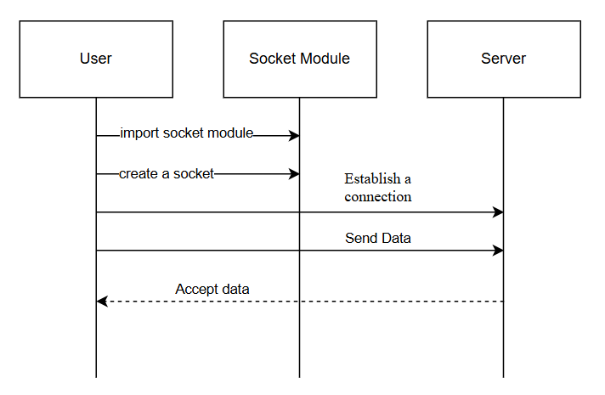

2.2 HTTP request & response
For HTTP requests and responses, the logical thinking is relatively simple. We need to check whether the requested data is received first, and then judge whether the requested data is valid. If it is valid, it is judged whether the requested resource address is the default address, if not, the default resource address is changed first, and then it is judged whether the request is a GET request, a POST request or a HEAD request according to the message type field in the message, and the corresponding request is processed accordingly. If not, an error status code 400 is returned.
The GET request is a query of resources. If the server queries the local resources corresponding to the request, it will package the response information and send it back. If not, it means that there is no local resource needed by the request, and return the status code of 404. Otherwise, it is OK status code 200. The HEAD request is similar to the GET request, but only the response header information is returned, but the response body content is not returned. Therefore, the HEAD request processing is included in the GET request processing, but there are some differences in the packaging of the response message.
POST is used to request the server to process the data, so what we need to do in the POST request is: = execute the corresponding script on the server according to the file name and parameters of the request, and return the execution result to the client as an HTTP response. If the file does not exist, return an error status 403; Otherwise, it is OK status code 200, and then the standard output is packaged into a response message after executing the subprocess.

2.3 thread pool management
Because we need to create multiple threads on the server to process the requests of multiple clients in parallel. We design the Worker class to inherit from the Thread class, and different instances of Worker are used to handle the needs of different clients. In particular, we need to manage the Thread pool, so the design inheritance class Thread Pool Manager inherits from the Thread class. Specifically, we use the queue to record all the current Worker threads, and the Thread Pool Manager is used to check whether the current number of threads has reached the set maximum. If so, the first Worker thread in the queue is destroyed and resources are released.

2.4 Pages and Databases
For the design of the page, we have a total of five html files. First, the home page is index.html, which contains two buttons: Calculator and Query. Click "Calculator" to jump to Calculator.html, and click "Query" to jump to Query.html. In Calculator.html, after entering two operands and selecting an operation symbol, click "=" to jump to Cal_res.html In Query.html, enter the Student ID of the student to be queried, and click "Submit" to jump to Que_res.html.

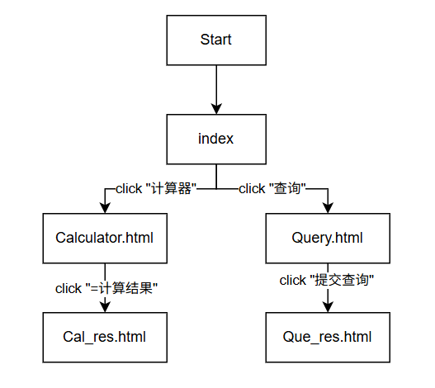
In addition, we have designed three error status code prompt pages, which are 400.html, 403.html, and 404.html respectively.
For the design of the database, we use a csv file to build the database, which is equipped with a relational data table about Student information. The keys contained in the database are Student ID, Name, Sex, Age, and Class, the primary key is Student ID.

2.5 CGI
In this experiment, we need to complete the design and implementation of two parts of CGI, namely the CGI of calculator and the CGI of database query.
For CGI of calculator, we need to write Calculator.py, take out the number to be calculated from the parameters, then judge the type of operation to be performed, perform the operation to get the result, and replace the result into Cal_res.html
For the CGI of database query, when querying, we use the data Student ID to query the complete information of students. We need to write Query.py, take out the Student ID to be searched from the parameters, and look it up in the database. Finally, we will replace the $data in Que_res.html with the found complete information.

- Development and Implementation
3.1 TCP Socket connect
port = 8888
server_socket = socket.socket(socket.AF_INET, socket.SoCK_STREAM)
host_name = socket.gethostname()
host_name = socket.gethostbyname(host_name)
address = ("0.0.0.0", port)
server_socket.setsockopt( socket.SOL_SOCKET, socket.S0_REUSEADDR, 1)
server_socket.bind(address )
server_socket.settimeout(60)
server_socket.listen(max_connection)

Receive message:
self.socket = tasks.get()
working_thread.append( self)
sema.release()
message = self.socket.recv(80o0).decode("utf-8")

3.2 HTTP request & response
def GET(self, file_name, is_head=False):
if (os.path.isfile(file_name)):
file_suffix = file_name.split('.')
file_suffix = file_suffix[-l].encode()
content = b"HTTP/1.1 200 OK\r\nContent-Type:text/"+file_suffix +b";charset=utf-8\r\n"
self.status_code = 200
else:
content = b"HTTP/1.1 404 Not Found\r\nContent-Type: text/html;charset=utf-8\r\n"
file_name = "404.html"
self.status_code = 404
content += b'\r\n'
self.socket.sendall(content)
file_size = 0
if not is_head:
self.file_handle = open(file_name, "rb")
for line in self.file_handle:
self.socket.sendall(line)
file_size = os.path.getsize(file_name)
self.write_log(file_size)

def POsT(self, file_name, args):
command = 'python + + file_name + + "+ + args + +" "+ + self.socket.getsockname()[0] + +" "''+ str(self.socket.getsockname()[1]) + *":
self.proc = subprocess.Popen( command, shell=True, stdout=subprocess.PIPE)
self.proc.wait()
file_size = 0
if (self.proc.poll() == 2):
content = b"HTTP/1.1 403 Forbidden\r\nContent-Type: text/html;charset=utf-8\r\n"
page = b'
self.file_handle = open("403.html", "rb")
for line in self.file_handle:
page += line
content += b'\r\n'
content += page
self.status_code = 403
else:
content = b"HTTP/1.1 200 0K\r\nContent-Type: text/html;charset=utf-8\r\n"
content += self.proc.stdout.read()
file_size = os.path.getsize(ile_name)
self.status_code = 200
self.socket.sendall(content)
self.write_log(file_size)

3.3 Thread Pool Manager
class ThreadPoolManager(threading.Thread):
def __init__(self, log_name):
threading.Thread.__init__(self)
self.setDaemon(True)
self.start()
self.log_name = log_name
def run(self):
for i in range(max_connection):
Worker( log_name)
while True:
for i in range(10):
if (len(working_thread) == max_connection and max_connection != 0 and (not tasks.empty())):
working_thread[0].restart()
sema.acquire(timeout=1)

3.4 Calculator script Calculator.py
import sys
try:
ini = sys.argv[1]
ini = ini.split("&")
a = ini[0].split("=")[1]
b = ini[1].split("=")[1]
c = “”
c = ini[2].split("=")[1]
res = “”
with open("cgi-bin/Cal_res.html", "r", encoding="utf-8") as f:
for line in f:
res += line
res = res.replace("$a", a)
res = res.replace("$b", b)
if c == "mul":
res = res.replace("$c","*")
res = res.replace("$res", str(float(a) * float(b)))
elif c == "div":
res = res.replace("$c", "/")
res = res.replace("$res", str(float(a) / float(b)))
elif c == "add":
res = res.replace("$c", "+")
res = res.replace("$res", str(float(a) + float(b)))
else:
res = res.replace("$c", "-")
res = res.replace("$res", str(float(a) - float(b)))
res = res.replace("$hostname", sys.argv[2])
res = res.replace("$port", sys.argv[3])
print( res)
except:
error_page = "
with open("400.html", "r", encoding="utf-8") as f:
for line in f:
error_page += line
print(error_page)

3.5 database Query script Query.py

import csv
import sys
ini = sys.argv[1]
hostname = sys.argv[2]
port = sys.argv[3]
student_id = ini.split("=")[1]
csv_file ='./data/Student_data.csv'
with open(csv_file,'r'，encoding='utf-8'） as f:
reader = csv.reader(f)
student_data = list(reader)
Get_res = 0
res = “”
with open("./cgi-bin/Que_res.html", "r", encoding="utf-8") as f:
for line in f:
res += line
for student in student_data:
if student[o] == student_id:
temp = "<tr>"
for i in range(5):
temp += "<th>" + student[i] + "</th>"
temp +="</tr>\n"
res = res.replace("$data", temp, 1)
Get_res = 1#说明找到了
if (not Get_res):
temp = "<p>Sorry, there's no correspoding data for your request.</p>\n"
res = res.replace("$data", temp, 1)
print( res)

- System Deployment, Startup, and Use
4.1 Project file structure
The file structure under the root directory is as follows:
Cgi-bin folder: it contains Cal_res.html and Que_res.html
Data folder: it contains Student_data.csv, which is the student information database.
Images folder: It contains pictures (static web pages) used in web pages. In this project, there is only one screenshot of the home page of Happy Learning.
Log folder: used to store log files. In the submitted project file, only one demo log file is put for display.
Server.py: the server main program.
Worker.py：worker main program of the worker thread class.
Calculator.py: Python script for calculator function implementation.
Query.py: Python script for database lookup.
Calculator.html: the main page of calculator function.
Query.html: the main page of database query function.
400.html: 400 error page.
403.html: 403 error page.
404.html: 404 error page.

4.2 Operation method
To run this project program, Python3 environment needs to be installed and configured. You can run it from the command line: pythonserver.py.
After running Server.py and entering Max Connection, as shown below, copy and paste the IP address and port in the standard output into the browser to open it.
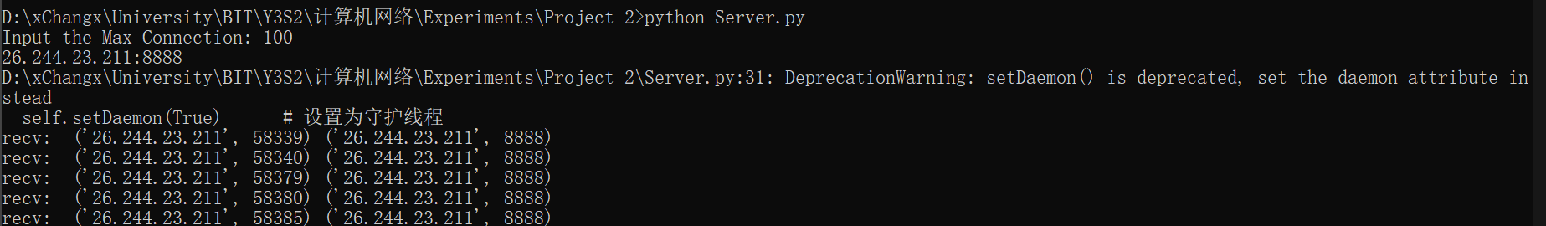

- System Test
5.1 unit test
For the Server.py test, when we connect normally, the log file can record GET/POST requests normally, as shown in the following figure.
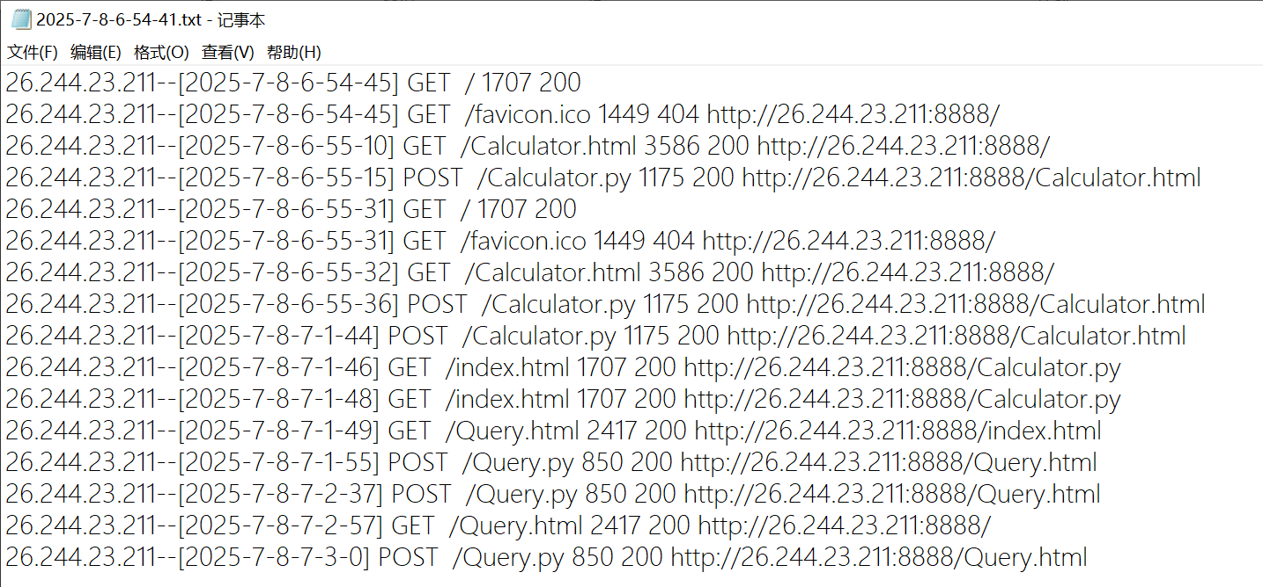
However, if there is no response for a long time, the timeout output will appear, as shown in the following figure.
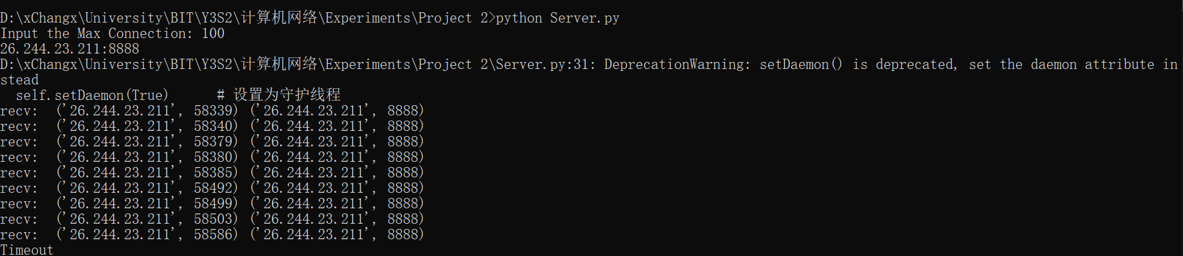
For the Worker test, we mainly test the log output part. For the log results shown in the preceding figure, the analysis results are the same as the Wireshark packet capture results, so the test is passed.

In addition, to test the GET request, if we enter a local resource, we should jump to the 404 error interface, as shown in the following figure.
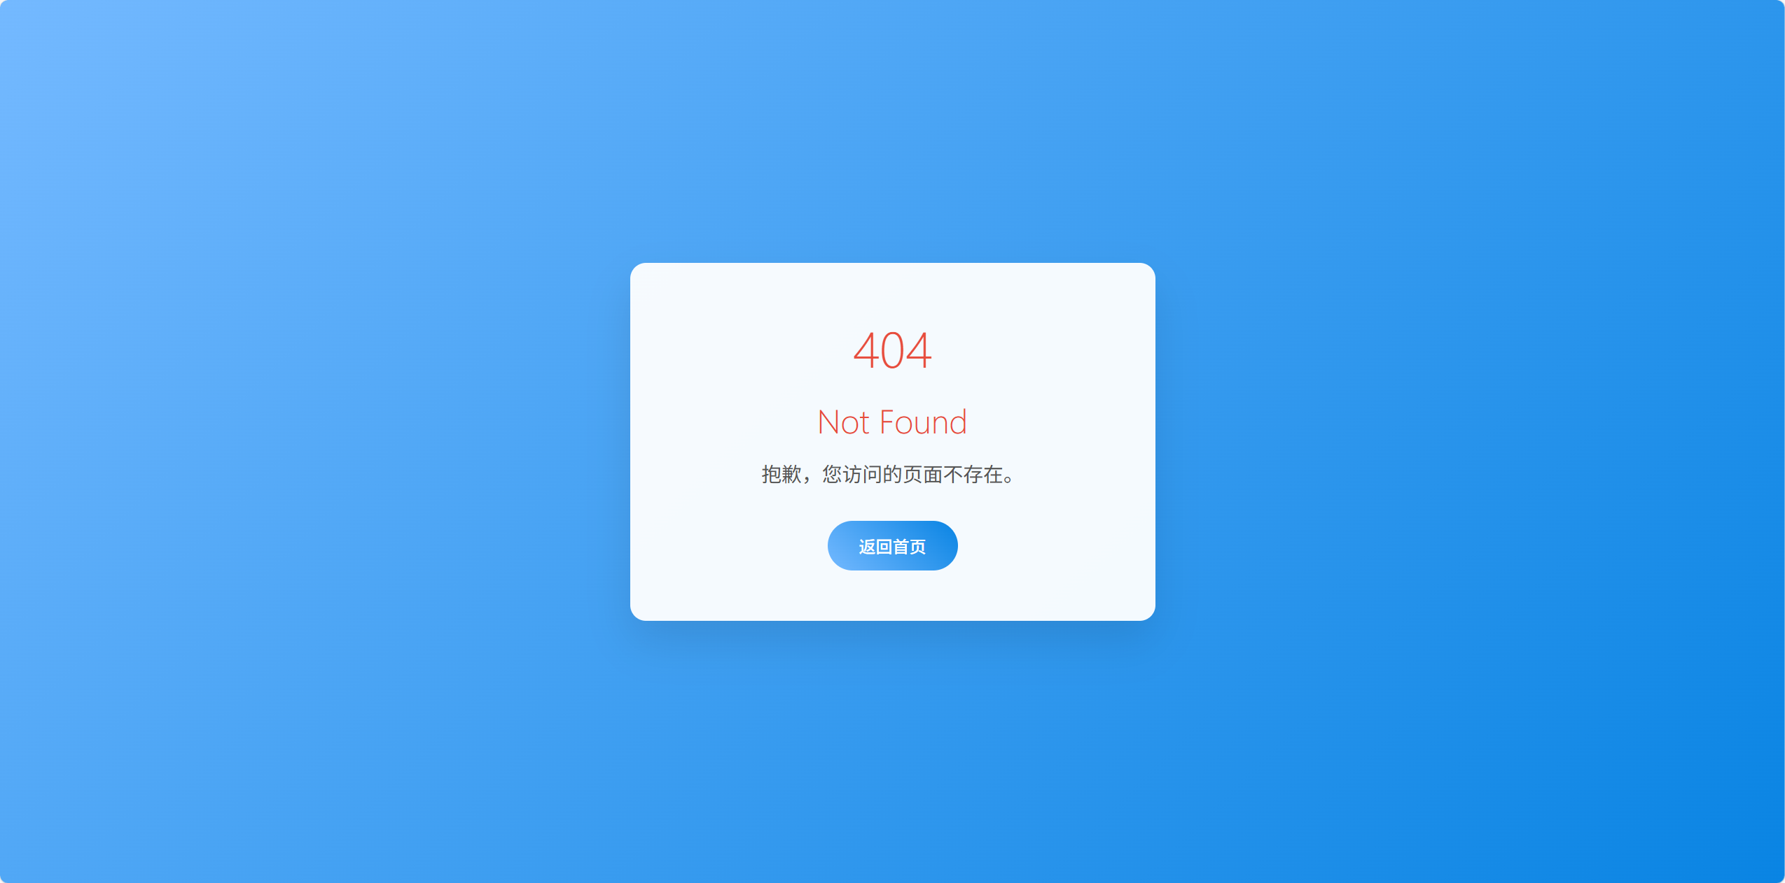

5.2 integration testing
First, test the function part of the calculator. After we enter two numbers and select the good luck symbol, click "=" to get the result. According to the way of dividing equivalence classes, we have conducted some tests, the result of the addition test is as follows:
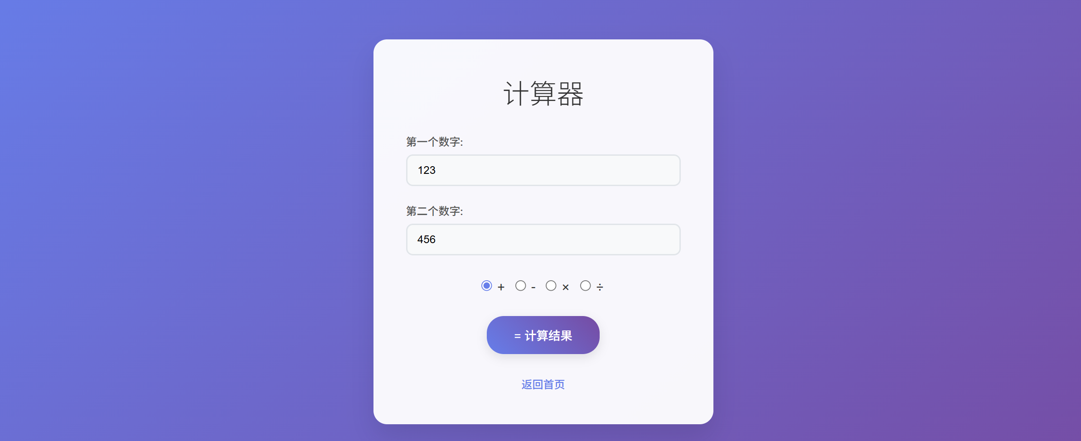
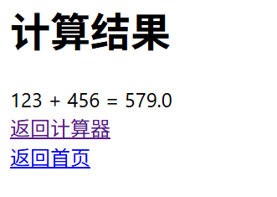
Then, test the database query and enter the Student ID existing in the database. The results are as follows:
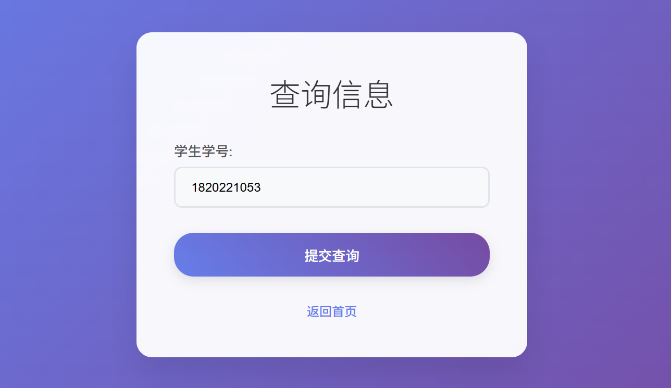
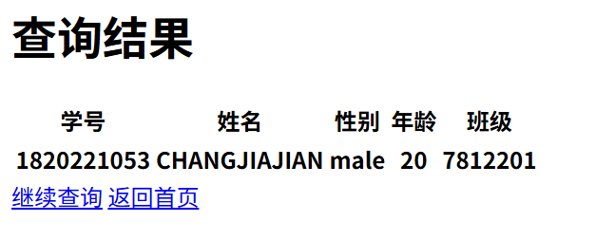
If the entered Student ID does not exist in the database, you will be prompted:
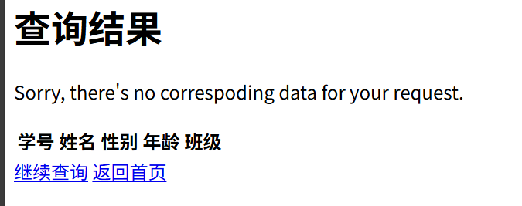
- Performance and Analysis
For Server.py, we will enter a Max Connection at the beginning. Obviously, if the number is larger, the upper limit of "pressure" on the server will be greater.
In this regard, if all the worker threads are busy at present, we can use the "blocking" method to block some threads first, and after the server completes some tasks, release the resources occupied by the threads that handle the tasks, so as to continue processing the currently blocked tasks.
After a simple test, the multi-threaded server built in this project has good stability and high transmission level in a certain range, that is, it will not miss some tasks and high data transmission rate.

- Summary or Conclusions
This project successfully implemented a multi-threaded web server with CGI support using Python, demonstrating several key networking and web development concepts:
Server Architecture: The implemented server effectively handles multiple concurrent connections (up to 20) using a thread pool management system, demonstrating proper resource allocation and connection handling.
Protocol Implementation: The server correctly processes HTTP/1.0 requests including GET, POST, and HEAD methods, with appropriate status code responses (200, 400, 403, 404) and corresponding error pages.
Dynamic Content: Through CGI implementation, the server successfully generates dynamic content for both calculator operations and database queries, showing the practical application of server-side processing.
Performance: The thread pool management system ensures efficient resource utilization, with the ability to handle connection limits and timeout scenarios properly.
Logging System: The implemented logging mechanism provides comprehensive tracking of server activities, which is crucial for maintenance and debugging.
The project successfully met all specified requirements while demonstrating good practices in web server development, concurrent programming, and error handling. The modular design (separate worker threads, CGI scripts) makes the system maintainable and extensible.

- References
[1] Python的socket库: https://blog.csdn.net/zsrwan/article/details/107082010
[2] Python Socket模块的介绍与简单使用: https://blog.csdn.net/qq_42967398/article/details/105
326616
[3] Python实现多线程: https://zhuanlan.zhihu.com/p/91601448
[4] CGI实现简易网页加法计算器功能: https://blog.csdn.net/zhyh1435589631/article/details/51
530926
[5] Vail, Cordell. "Stress, load, volume, performance, benchmark and base line testing tool evaluation and comparison." Tersedia: http://vcaa. com/tools/loadtesttoolevaluationchart-023. pdf (2005).

- Comments
This project was particularly valuable for understanding:
The complete lifecycle of HTTP requests/responses
Practical challenges in concurrent server implementation
The interaction between web servers and CGI programs
Importance of proper error handling and logging
The hands-on experience with socket programming, thread management, and web protocols significantly deepened my understanding of computer networks and web technologies. The project successfully bridged theoretical knowledge with practical implementation skills.

